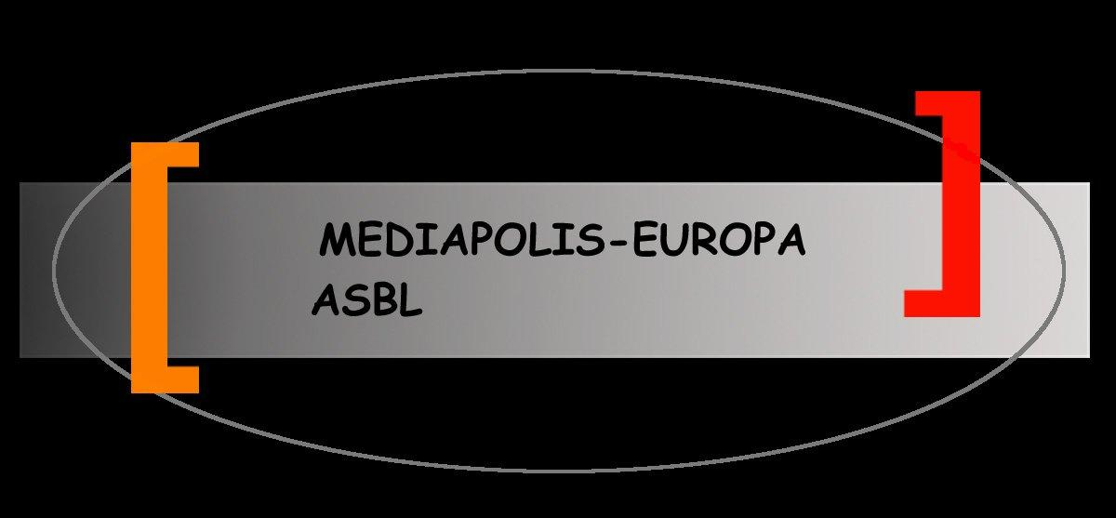
Osservatorio scientifico della memoria scritta,orale, filmica e del patrimonio autobiografico

Direction
Beatrice Barbalato

Management
Irene Meliciani

Scientific Comitee
Fabio Cismondi
(Fusion for Energy-EU)
Albert Mingelgrün
(Université libre de Bruxelles)
Giulia Pelillo
(Universität Heidelberg)
Edgar Radtke
(Universität Heidelberg)

MEMBERSHIP FORM

Membership is per calendar year

Type of Membership □ New □ Renewal

Contact Person: Given Name: _________________ Surname:___________________
School / Organisation: ___________________________________________
Mailing Address:____________________________________________________
_____________________________________ Post Code: ___________________
Contact Number: _________________ ______________________________
Email address:___________________________________________________

Payment Details:
The membership fee of 25€ can be paid by bank transfer to the bank account of the Association Maediapolis:
Banca Monte Paschi del Belgio BE 42 643-0021608-54
BIC BMPBBEBB

